Project Report: News Search and Sentiment Analysis Tool
Overview
This project is a web-based application that enables users to search for recent news articles related to a specific topic and analyze the sentiment of those articles. It utilizes APIs and AI-driven natural language processing to deliver insightful feedback on news content.

Technologies Used
- Python
- Streamlit: For building the interactive web application.
- LangChain + OpenAI API: For performing sentiment analysis using a large language model.
- NewsAPI: To fetch real-time news articles.
- dotenv: For securely managing API keys.

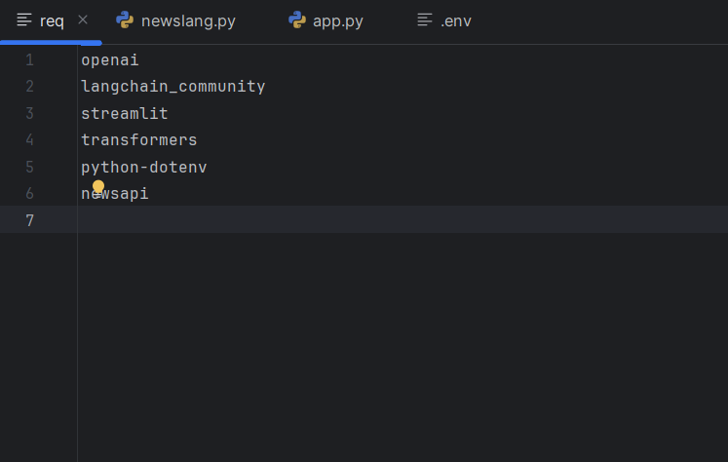

Working
- User Interface (app.py):
  - A simple interface is created with Streamlit where users can enter a search query.
  - On clicking the “Analyse NEWS” button, the app fetches relevant articles and analyzes the sentiment of the first one.
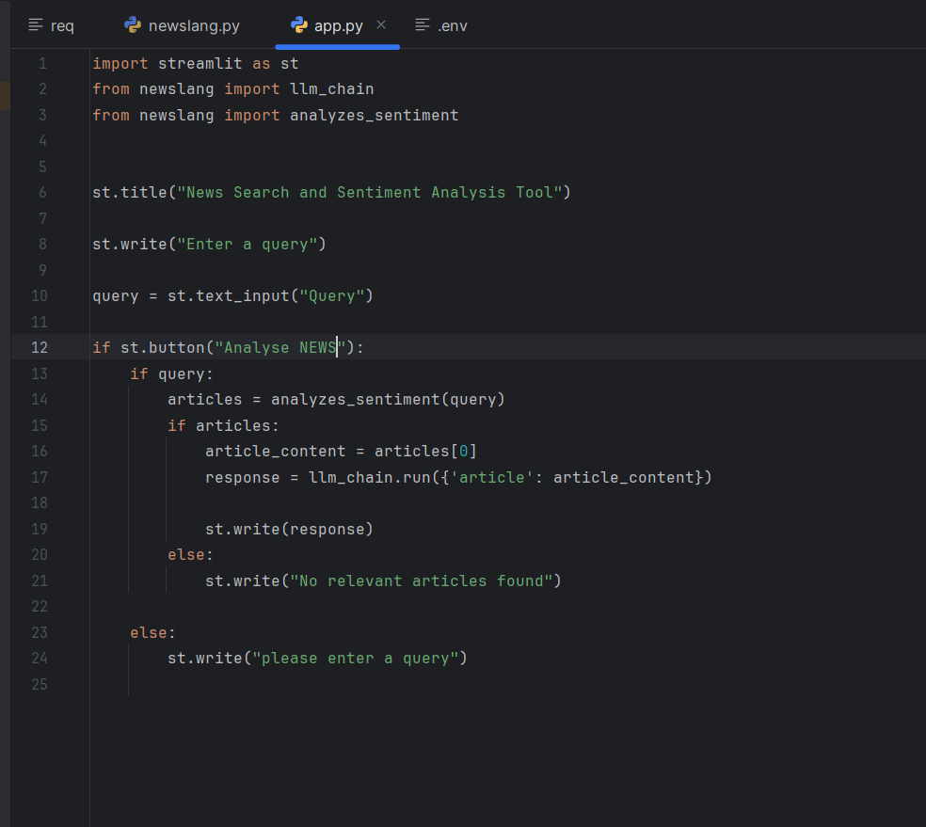
- Article Retrieval and Analysis (newslang.py):
  - NewsAPI is used to fetch news articles based on the user's query.

  - The content of the first article is extracted and trimmed.
  - A prompt is created using LangChain's PromptTemplate, asking the OpenAI model to analyze sentiment.
  - The sentiment (positive, negative, or neutral) is returned and displayed to the user.

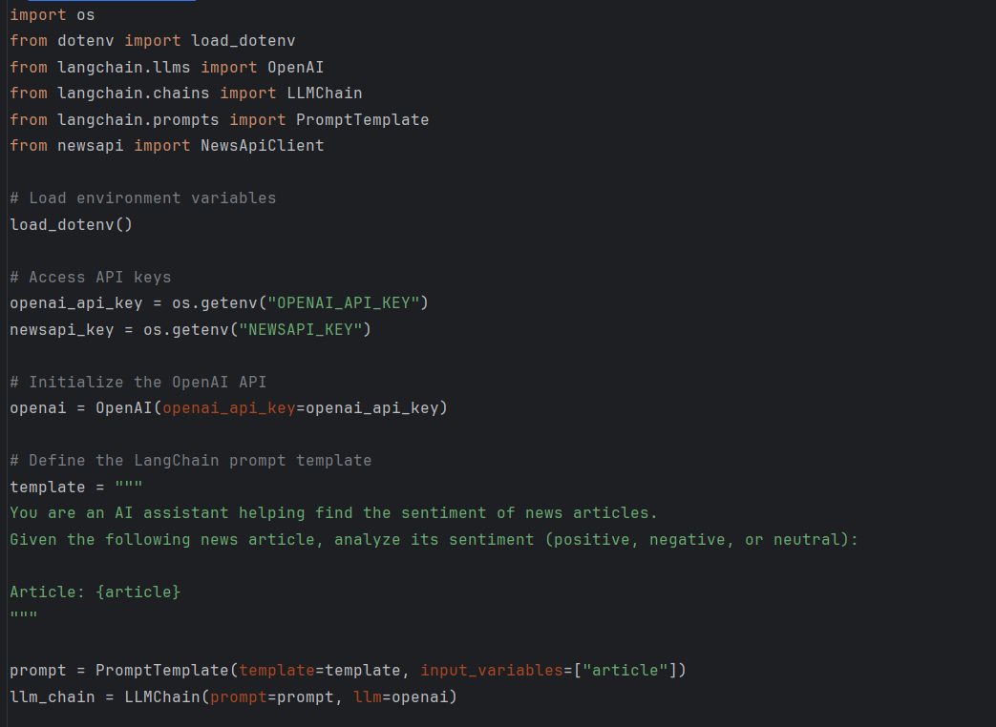
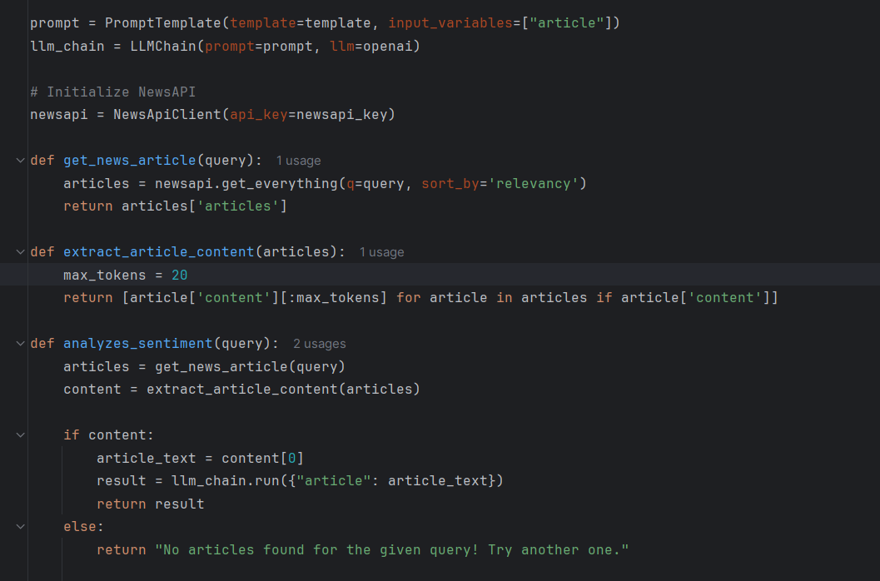

- Security (.env):
  - API keys are stored in a .env file for security and accessed using the dotenv package.
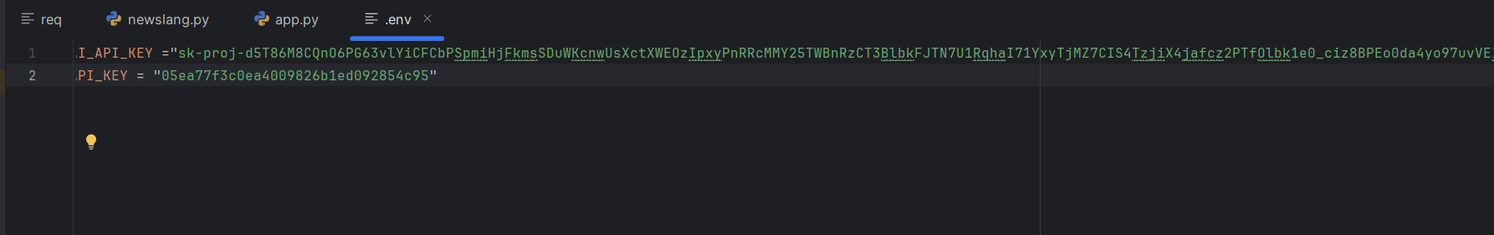

Key Features
- Real-time news fetching.
- Automated sentiment analysis powered by OpenAI.
- Simple and user-friendly interface.
- Clean modular code using best practices like environment variable management and separation of concerns.

Limitations & Suggestions
- Currently analyzes only the first article returned by the NewsAPI.
- Only a snippet (first 20 tokens) of the article content is used, which may limit analysis quality.
- Could be improved by:
  - Processing more articles for a broader sentiment picture.
  - Using more of the article content (while managing token limits).
  - Displaying a summary alongside the sentiment.

